Name: Mann Roll no: 16010123192

Git add .
Git commit
Git push

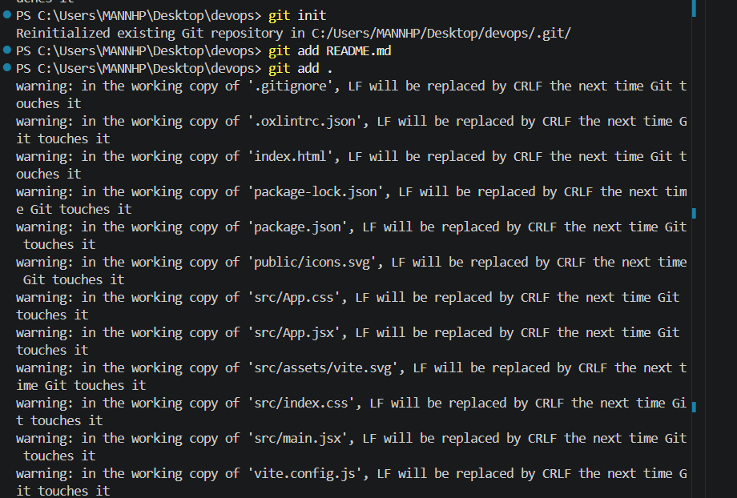

Git init
Git add
Git status
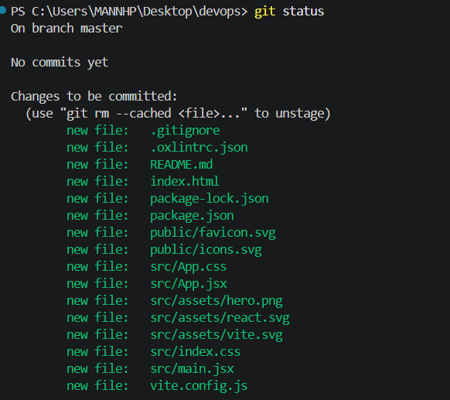
Git branch
Git remote add origin
Git push -u origin
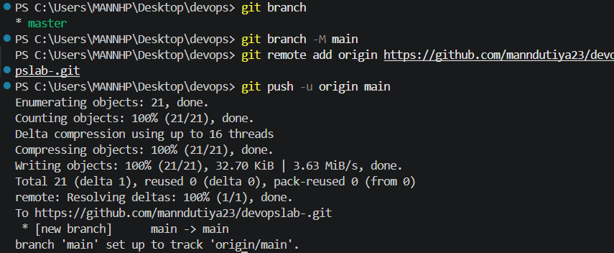

Git switch -c
git checkout
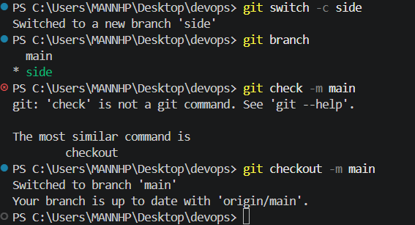

git branch --sort=-committerdate
git branch -d
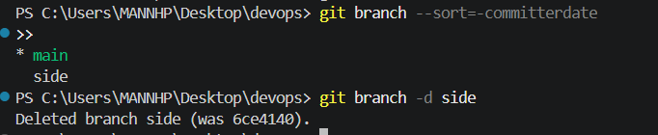
Diff Staged/Unstaged Changes and Combine Diverged Branches
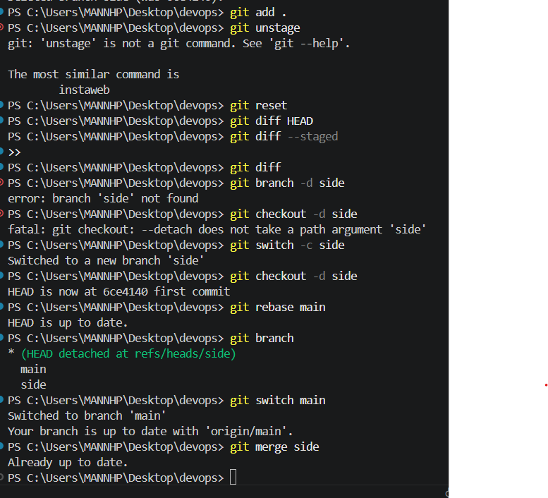
Git pull
